

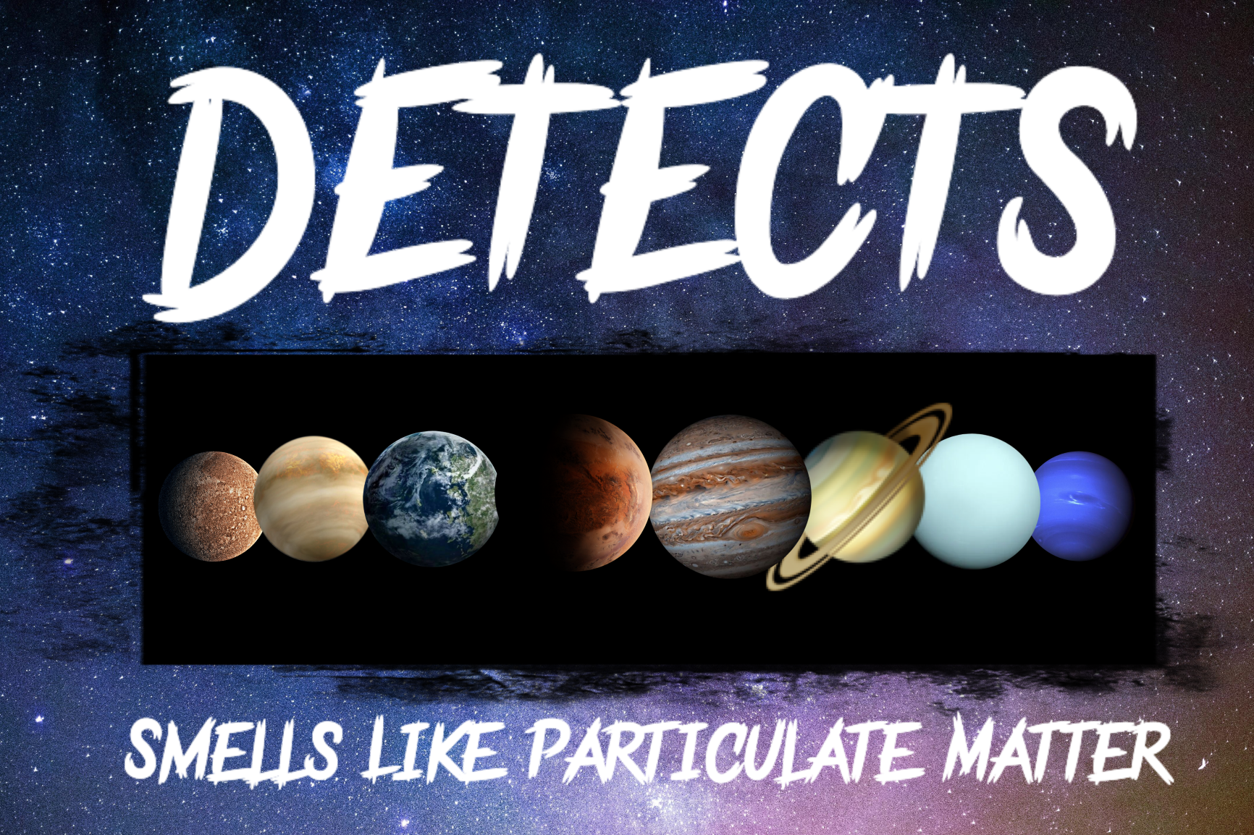

# Introduction

This team is named “Smells Like Particulate Matter” and is part of the Data Evaluation From Testing via an Educational Challenge with Teachers and Students (DETECTS) initiative with the University of Alabama in Huntsville (UAH). The DETECTS mission will take place in ACES RED 2B (AR2B) on an external pallet attached to the ISS (International Space Station). AR2B’s primary objective is to study the quantum entanglement technology in space satellite communications. The primary purpose of DETECTS on AR2B is to investigate the use of low-cost commercial-off-the-shelf (COTS) hardware. The team’s mission is to develop an experiment that utilizes a Raspberry Pi computer in conjunction with sensors to fulfill a scientific objective. This team must select a scientific objective to build an experiment around, program the Pi, and confirm that it meets all functional and environmental requirements through testing. The team must do this all while working together to successfully communicate their progress with a panel of evaluators.

All DETECTS teams were given a very detailed Request for Experiment (RFE) and Interface Control Document (ICD) with the requirements that must be met in order to qualify for a slot on AR2B. The experiment would be stored in AR2B, where it would generate and relay data back to the team for evaluation. The project requirements for the team’s experiment is broken down into four categories. The team must follow mechanical and spatial requirements by keeping the experiment no larger than 65 mm by 56.5 mm by 19 mm, and by not modifying the existing Pi mounting configuration or the existing 40W connector pins. Electrical requirements detail that the experiment must be compatible with the existing 40W pinout and that the team cannot use pins 30 or 31. Mechanical aspects of the experiment must be stationary and solid to avoid any damage to the experiment and AR2B. The team cannot include: liquids or gasses of any kind, organic material, loose or powdered material, high voltage equipment (>28V), EMF producing equipment (>6 gauss), pressurized vessels, moving parts, reconfigured pinouts, fracturing or shattering materials, batteries, or electrolytic capacitors. In terms of software, all programs must be able to interface and collect data from a Pi HAT and not exceed a data rate of 5 kilobytes per second (kBps). Also, the team must be able to communicate with the AR2B flight computer via this team’s unique JSON packets passed to UAH’s team sender program through placement in the /tmp/experiment directory.

# Science Objective and Instrumentation

This team came up with a total of three potential science objectives, “Material Reflectivity”, “Commercial Grade Contaminants Comparison”, and “Fiber Optic Radioactivity.” Material Reflectivity would measure the reflectivity of specific materials with a reflectance sensor within the near-zero lux environment of the AR2B tray. Many consumer technology devices, such as screens, use reflectivity to function, allowing for research on this subject to possibly benefit the use of such technology in extraplanetary missions. Commercial Grade Contaminants Comparison would be studying and assessing the particulate matter present on AR2B utilizing a particulate matter sensor. This would help figure out the real difference between consumer and professional-grade sensors. Fiber Optic Radioactivity would look at and study the effects of background radiation on fiber optic cabling by utilizing a simple voltage output and input to measure any losses. This is key to figuring out what effect spatial radiation has on connectivity with fiber optics. In order to choose a scientific objective to pursue, the team used a science objective trade study (chart pictured in Table 1) with weighted figures of merit or FOMs. The FOMs assigned by UAH were Interest of Team, Measurement Method, Likelihood of Success, Sensor Complexity, Sensor Resolution, and Scientific Ramifications. In addition, this team added three other FOMs, Justifiability, Public Interest, and Public Comprehension respectively. All FOMs were given a weight of either 1, 3, or 9. After careful debate and research, “Commercial Grade Contaminants Comparison” won with a weighted score of 337, due to its high scores in Measurement Method, Likelihood of Success, and Interest of Team. The high score in Measurement Method was due to the highly tested nature and quality of the instrument, and high scores in likelihood of success are due to the stability of the experiment’s design in concept and programming.

“Commercial Grade Contaminants Comparison” will establish an experiment to compare the quality and quantity of data collected by commercial-grade vs professional-grade equipment. In order to do this, the team will assess particulate density, prevalence, size, and levels over time while onboard ACES RED 2B in order to proceed with a data comparison analysis. All of this will be done in order to gather data on the difference in both the quality and quantity of measurements between consumer and professional-grade sensor technology. After some research on different types of sensing technology, the team has come to believe that the inaccuracy of data generated by commercial-grade sensing technology will not be impressive enough to warrant the costs typically associated with the more expensive professional equipment. The goal in mind for this experiment is to determine whether or not commercial-grade sensors and COTS (“Commercial off the Shelf”) hardware are accurate and reliable enough to be used in future missions. If the data gathered from the prospective experiment provides evidence in support of this claim, COTS equipment may be able to replace or supplement far more expensive sensors that have similar purposes. In order to complete the science objective, the experiment must be able to measure particulate density, prevalence, size, and levels over time. Also, the sensor must be able to take measurements on AR2B. After some research, the team decided on the Sensirion Particulate Sensor 30 (SPS30), a consumer-grade particulate matter sensor (See Science traceability Matrix, Table 2). The SPS30 features a compact design, measuring 40.6 mm x 40.6 mm x 12.2 mm, and can measure particulate matter as small as 0.3 μm, a figure slightly better than the posted value for the ISS’s Analysing Interferometer for Ambient Air (ANITA), otherwise known as the ISS’s current air quality monitoring system. The sensor also features an impressive accuracy of +/-10 μg/m^3, as well as a long term accuracy drift of +/- 1.25 μg/m^3 per year and a pi compatible digital output. The SPS30’s small profile combined with very high accuracy and reliability appear to simply outperform all of the other consumer-grade sensors the team found while researching. Due to the design of the SPS30 intake and the microgravity conditions the experiment will experience, the experiment will be able to take highly accurate measurements simply by running and has no notable limiting requirements. In table 2, the team describes the process through which this team went to determine the best sensor for this team’s science objective.

The reason the team chose to research a particulate matter sensor, in particular, is based on research the team has done into the ISS’s current air quality monitoring system, the aforementioned ANITA. It is a system that can measure particulate matter up to the “high parts per billion” or 0.5-9 μm range, as well as to detect over 32 different types of harmful trace gasses. It was developed in the early 2000s, and presumably cost multiple millions of dollars to produce, engineer, design, and qualify. This team’s experiment includes a $45 sensor that can detect smaller particles (0.3 μm) with a very high degree of accuracy. This team believes that the current particulate matter sensors used in spaceflight missions may be outdated, and by extension, the laser-based measurement technology as seen in sensors like the SPS30 may prove more accurate than the infrared technology used in older sensors such as the one integrated into ANITA. This team believes that an SPS30 may be able to produce results with comparable or higher accuracy to the existing ANITA system, with the added perk of a price point less than 0.001% of the cost of the existing technology (assuming the particulate sensor in ANITA cost at least 5 million to develop, engineer, and implement). With this stated, this team is by no means questioning the accuracy or engineering of the ANITA, as sensing particulate matter is just one of many functions it performs. The above explanation of the ANITA is by no means all-encompassing, and a device like SPS30 could never replace such a system by itself. However, validating the accuracy and usability of a COTS device such as the SPS30 aligns very well with the secondary objective of AR2B, and could potentially have very important implications in terms of future mission costs as explained above, and could also lead to new, more accurate systems being created with these new technologies.

Table 1. Science Objective Trade Study

| FOM | Weight | Material Reflectivity | | ACES RED 2B Contaminants Comparison | | Fiber Optic Radioactivity | |
| --- | --- | --- | --- | --- | --- | --- | --- |
| Raw | Weighted | Raw | Weighted | Raw | Weighted |
| Interest of Team | 9 | 3 | 27 | 3 | 27 | 9 | 81 |
| Measurement Method | 9 | 9 | 81 | 9 | 81 | 3 | 27 |
| Likelihood of success | 9 | 3 | 27 | 9 | 81 | 3 | 27 |
| Sensor Complexity | 3 | 3 | 9 | 9 | 27 | 3 | 9 |
| Sensor Resolution | 3 | 3 | 9 | 9 | 27 | 3 | 9 |
| Scientific Ramifications | 1 | 1 | 1 | 9 | 9 | 9 | 9 |
| **Justifiability** | 9 | 1 | 9 | 9 | 81 | 3 | 27 |
| **Public Comprehension** | 1 | 3 | 3 | 3 | 3 | 1 | 1 |
| **Public Interest** | 1 | 3 | 3 | 1 | 1 | 1 | 1 |
| **TOTAL** | | Sum: 169 | | Sum: 337 | | Sum: 191 | |

Table 2. Science Traceability Matrix

| **Science Objective** | **Measurement Objective** | **Measurement Requirement** | **Instrument Selected** |
| --- | --- | --- | --- |
| Commercial-Grade Contaminants Comparison | Measure Particulate density, prevalence, size, and levels over time. | Be able to collect particulate data from ACES RED 2B. | Sensirion Particulate Sensor 30 |

# Configuration

The team’s mission utilizes an SPS30 mounted on a custom Raspberry Pi Hardware Attached on Top (HAT). The HAT is a printed circuit board (PCB) with dimensions of 65 x 56.5 x 0.8 millimeters. This HAT integrates the selected sensor, the SPS30, by mounting it via solder anchor points and a connector for the sensor. This allows for a stable mount throughout the course of the mission. The HAT design also allows for the use of the 5 pin connector standard utilized by the SPS30, to allow for ease of installation and troubleshooting. Additionally, the HAT meets all the requirements for a Pi HAT, such as utilizing all 40 general-purpose input/output (GPIO) pins and having all the correct solder trace placement rules. The HAT is mounted utilizing 6mm brass standoffs, to ensure the most stability when AR2B encounters inclement conditions. As depicted in figures 1, 2, and 3, the SPS30 will be roughly centered on the Pi HAT and will be connected to the GPIO pins via the traces and solder connection pads seen in figure 1.

Figure 1. HAT CAD Figure 2. 3D CAD

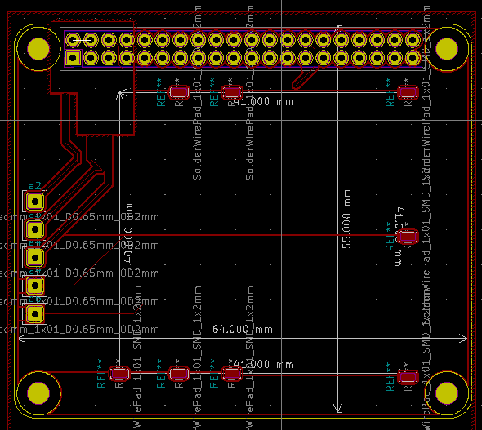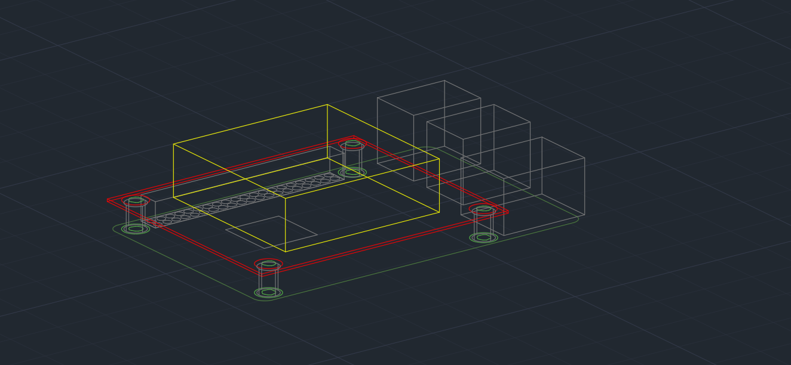

Figure 3. CAD Side View Figure 4: Concept of Operations Flowchart

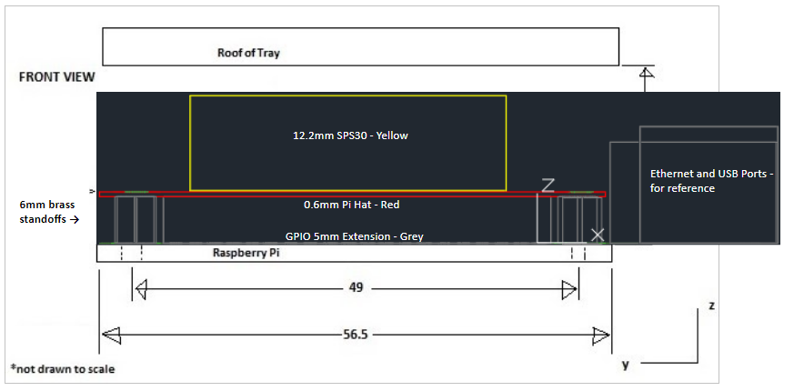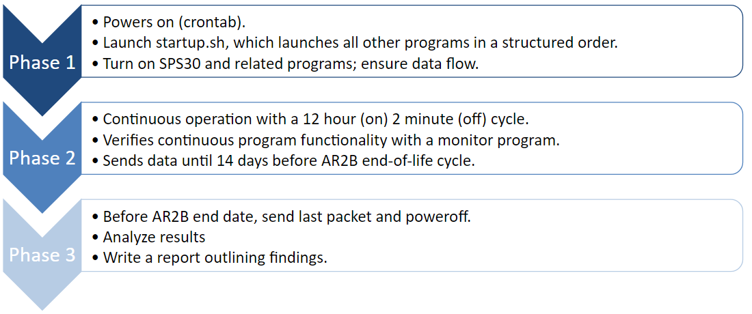

# Concept of Operations

This experiment divides its concept of operations into three phases. Phase 1 is dedicated to powering up and utilizes a cron job to launch all of the required programs. During this phase, the SPS30 also powers on, and test data packets are sent to ensure that all the required programs started correctly. During Phase 2, the experiment operates for twelve hours at a time, then stops and restarts for approximately two minutes. This restart period serves to ensure that if any errors are missed by the monitor program during the mission, a minimal amount of data would be lost. Additionally, the aforementioned monitoring program ensures that all programs are functioning properly by performing a soft restart (SPS30 power is not cut) if an error occurs. During this phase, the experiment sends data to the AR2B data handling system at a max data rate of 0.5 kilobytes per second. During Phase 3, the experiment sends its last data packet and powers off approximately 14 days before the end date of AR2B. This is to ensure that little data is lost, while also ensuring that the team does not interfere with AR2B’s end of life plans. After the team receives all the data from the experiment, the team will look for any statistically significant data present, and then create a report outlining the findings, and the implications thereof. This team’s concept of operations is depicted visually in figure 4.

# Programming

The team’s mission program consists of five crucial programs: A startup program, a sensor program, a transfer program, a monitor program, and UAH’s program. Figure 1 shows the basic operation of the programs. In Figure 1, the team uses green lines to represent the data cycle of the program, red lines to represent a triggered restart, and the blue lines represent the log cycle.

The startup program is launched as part of the pi’s bootup sequence through a feature built into the native Linux-based operating system called a cron job. This cron job runs automatically as part of the Pi bootup sequence and launches the startup program. Then, the startup program initializes and launches all of the programs needed for the mission, as well as starting a twelve-hour restart timer. The startup program is written in bash due to bash’s compatibility with the native shell.

The startup program launches the monitor program two minutes after the pi’s bootup sequence completes. This allows time for all of the other programs to launch and begin functioning properly. After the two minutes are elapsed, the monitor program checks to make sure that all other programs are running. If a program has terminated or stopped producing data, the monitor program will initiate a soft system restart. The monitor program is written in Python.

The startup program also launches the sensor program (immediately). The sensor program, written in Python, configures the sensor by writing to control registers embedded in the physical sensor and then proceeds to read data from the sensor’s output registers. This data is collected by the pi utilizing the I2C protocol and is packaged into a timestamped JSON file no more than sixty times per minute. Because each data packet is approximately 500 bytes, the maximum data rate of the experiment is 0.5 kBps. The data output from the sensor includes particulate matter size (<0.5μg, <1μg, <4μg, <10μg, >10μg) and particulate matter prevalence (μg/m3). All of this data is very useful for validating the accuracy and reliability of the SPS30. Specifically, this gathered data will be analyzed by the team and compared to predicted results, testing results, prior mission results, and any other data figures relevant to the collected data. Depicted in figure 2 is a screenshot of a JSON data packet assembled by the sensor program.

The transfer program is a very simple program designed simply to move the timestamped JSON files to the /tmp/experiment directory (folder) as required by the DETECTS ICD. All this program does is make the /tmp/experiment directory, as it is intentionally deleted by the system with every reboot, and it moves all JSON files to the /tmp/experiment directory to be handled by UAH’s program. The transfer program is written in bash.

Figure 5: Program Flowchart Figure 6: Example Data Packet

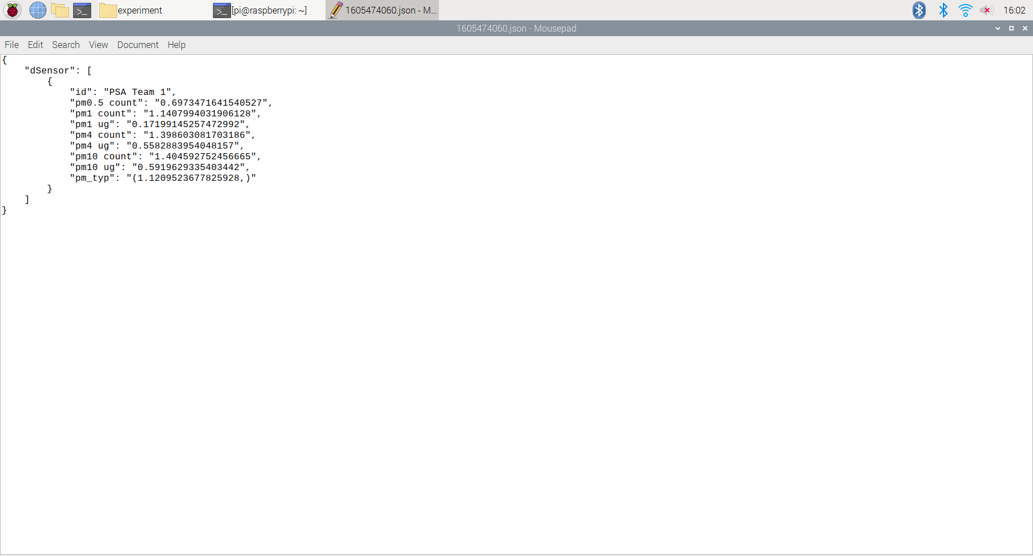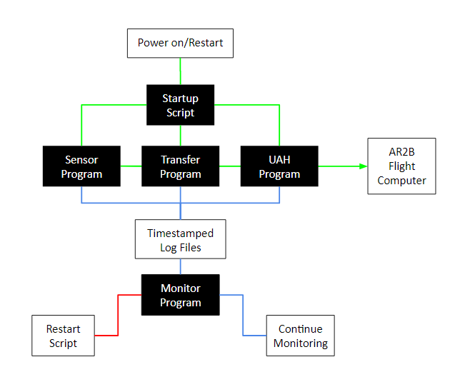

# Functional and Environmental Requirements

While onboard AR2B, the experiment will have to remain functional within the environment. As defined by the RFE and ICD, there are certain functional requirements alongside several environmental requirements that must be met in order to qualify as a sub experiment for AR2B.

In order to meet the basic functional requirements laid out by the RFE and ICD, the experiment must be able to take measurements, organize data packets, and send data. This team chose to include several more requirements to better suit the mission and demonstrate this team’s focus on safety and reliability. These additional tests include establishing an accurate particulate count with the sensor as well as handling program errors and resuming operation after a reboot. The latter two requirements were added in order to take into account unpredictable or unexpected errors that may occur during the mission.

To be able to meet the environmental requirements, the experiment must survive the conditions that will be experienced while aboard AR2B. These environmental conditions include surviving extreme temperatures (less than -20℃ and greater than 90℃), collecting and sending data inside a vacuum, and remaining functional after experiencing up to 4 gs of random vibration. In addition to the aforementioned requirements, the experiment must maintain structural integrity while experiencing these environmental conditions. These conditions could be detrimental to certain components and electrical equipment as such each condition must be tested in order to ensure that the experiment remains functional throughout the mission.

# Test Plan

A test plan was developed in order to meet the functional and environmental requirements necessary to succeed within the mission. As such a functional test plan and an environmental test plan was designed and scheduled in order to meet each set of requirements. The initial functional tests, as shown in Table 3, include the Sensor Test, the Transfer Test, and the Recovery Test.

The first initial functional test, the Sensor test, was made to determine if the experiment can take measurements, and establish an accurate particle count within a margin of error. The sensor is a crucial part of the mission, so this test looked for any issues with the sensor before proceeding with any other test. This test was completed by running the sensor in a well-ventilated room and verifying basic functionality and accuracy. The test was run successfully as the program worked as expected, had no errors, and remained accurate, as pictured in Figure 7. During the upcoming testing phase of the project, the team plans on reiterating the test using a known particulate source, such as a burning candle, and comparing the SPS30 particulate count with the actual particulate count.

The Transfer Test was this team’s second initial functional test, and it was made to determine if the experiment can organize data packets and send data. In order to properly send the data, the UAH transfer program was used alongside this team’s own transfer program. A test was set up to determine whether or not JSON data packets generated by the SPS30 interface program were transferred successfully to the /tmp/experiment directory and collected by UAH’s program. Since the UAH program deletes the JSON packets after sending them, it was disabled once to gather a screenshot of a populated /tmp/experiment directory, pictured in Figure 8. This test ran 25 times with 0 failures. The transfer program was successful in transferring the time-stamped files to the /tmp/experiment directory, and per the UAH transfer program, the experiment has a current maximum of 0.5 kBps and an average of 0.3kBps for data rate.

The final initial functional test is the Recovery Test, which determines if the experiment can handle program errors and resume operation after a reboot. This test was created to verify if the program can handle power loss, errors, and other unpredictable exceptions. The experiment would be put through a multitude of possible errors including unplugging the SPS30 GPIO wires, killing the programs, and cutting the power. The test was run over 50 times with the experiment succeeding in starting back up after reboot every time. The monitor program succeeded in detecting and recovering from all conceived errors as data collected after each test remained consistent with the data collected prior to testing.

Table 3: The Functional Test Plan

| Functional Test | Requirement | Status | Comments |
| --- | --- | --- | --- |
| Sensor Test | Take measurements; Establish an accurate particle count | Completed; Passed | Able to determine particle count, values are accurate and consistent. |
| Transfer Test | Organize Data Packets; Send Data | Completed; Passed | The data rate can be adjusted by changing measurement frequency. |
| Recovery Test | Handle Program Errors; Resume operation after reboot | Completed; Passed | Verify that the programs can handle power loss, errors, and other unpredictable exceptions. |

Figure 7: Accurate Particulate Matter Readings Figure 8: Populated /tmp/experiment Directory

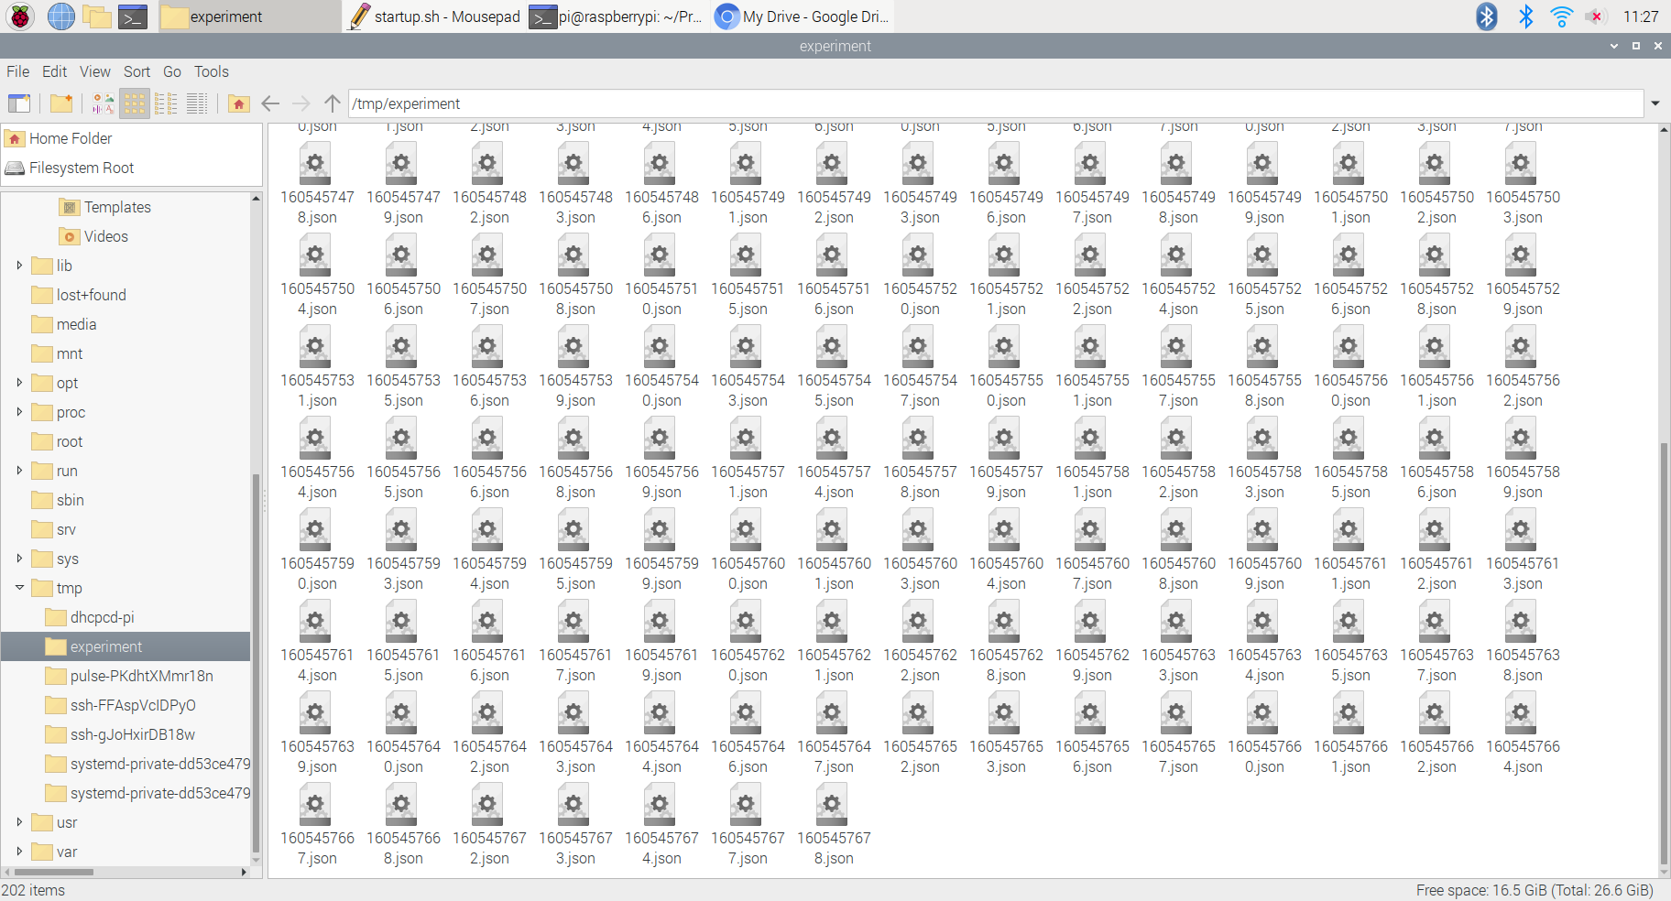

The environmental tests shown in Table 4 include the Heat Test, the Cooling Test, the Vacuum Test, and the Rumble Test. These tests were designed to simulate conditions onboard AR2B and have been scheduled for the second week of January.

The first test is the heat test, testing whether the experiment can take measurements in temperatures up to 90 degrees Celsius for an extended period of time. The test will be performed using a toaster oven provided by UAH to heat the temperature range in which the experiment remains functional. During this test, the team will monitor the temperature closely to determine the exact range that the experiment remains functional with a thermocouple also provided by UAH. The Cooling test will determine if the experiment can take measurements in cooler temperatures, and will be tested using a freezer and a sealed container for moisture control. The UAH provided thermocouple will again be used to gauge the temperature range the experiment remains functional.

Next, the Vacuum test will determine if the experiment can take measurements, maintain structural integrity, and survive extremely low pressures. The experiment will also be subject to vacuum-like conditions and will utilize a UAH provided vacuum chamber. In addition, the experiment will be secured in a fixed location during the Vacuum test and the hardware integrity will be checked prior to testing. Finally, the Rumble Test, a test made to determine if the experiment could take measurements, maintain structural integrity, and survive random vibrations. UAH will provide an accelerometer for the rumble test and, like the Vacuum test, the hardware will be checked prior to testing.

Table 4: The Environmental Test Plan

| Functional Test | Requirement | Materials | Test Date | Status | Comments |
| --- | --- | --- | --- | --- | --- |
| Heat Test | Take Measurements, Survive Hot Environment | UAH Provided Toaster Oven and Thermocouple | Jan. 11th | Scheduled | Monitor closely. |
| Cooling Test | Take Measurements, Survive Cold Environment | Freezer and UAH Provided Thermocouple | Jan. 12th | Scheduled | Moisture controlled. |
| Vacuum Test | Take Measurements, Maintain Structural Integrity, Survive Extreme Pressures | UAH Provided Vacuum Chamber | Jan 13th | Scheduled | Check hardware prior to testing. |
| Rumble Test | Take Measurements, Maintain Structural Integrity, Survive Random Vibrations | UAH Provided Accelerometer | Jan 14th | Scheduled | Check hardware prior to testing. |

# Online Outreach Platform

Outreach’s goal was to create and run an online forum through multiple social media platforms that engage and educate the audience. To complete the Outreach requirements for the DETECTS mission, the team created a host of platforms including a website, an Instagram, and a youtube channel. The team created a website as a “home-base” where the team could present all basic information in relation to the team and post links to other platforms. The team selected Instagram for its popularity, relatability, and presentation of information. It is widely used by the K-Adult age range, the age group the team is trying to target. In addition, it’s highly adaptable. Youtube was added to this team’s selected platforms as a location from which the team can upload more personal, engaging content such as activity videos. All platforms the team has chosen are very effective in engaging users in an easy to use format. Throughout the first portion of this project, the team experimented with different formats of outreach activities, all of which have required a lot of planning. The team currently has a solid homepage and information center on this team’s website, a channel trailer on this team’s Youtube channel, and a solid post foundation on this team’s Instagram.

In the upcoming semester, outreach is prepared and ready to begin the phase of content creation and publishing. The team is anticipating a significant increase in following and engagement from all platforms from this point forward as this team’s content becomes more detailed and specific to this team’s work. The plan for next semester is mainly content output and finalizing survey collection at a date yet to be determined in addition to the collected data’s analysis. Currently in production are two activity videos and an explanatory video about this team and mission specifics.

So far this team has collected 688 surveys and shown below in figures 9, 10, 11, and 12 are charts that visually represent the data this team has collected so far. At this point in the survey collection, a majority of the responses have been submitted by female individuals. That may, at this point, sway the data in a certain direction.

Figure 9. Importance of Science Averages Figure 10. Importance of Math Averages

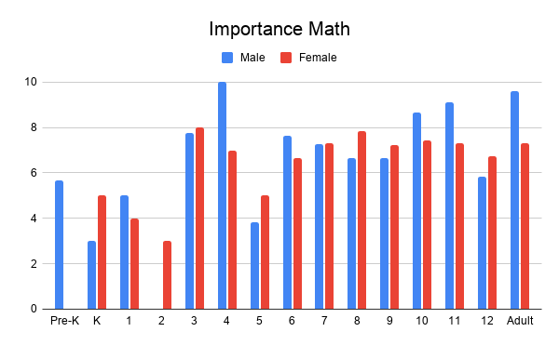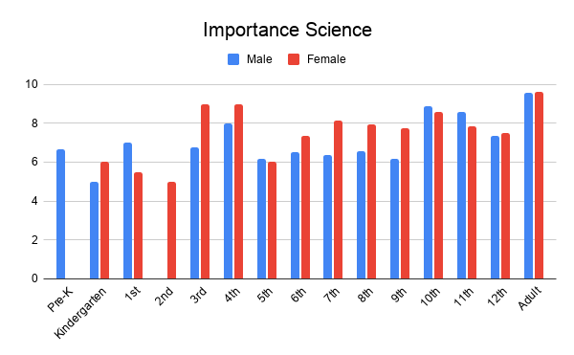

Figure 11. Liking Math Averages Figure 12. Liking Science Averages

Starting with the average scores given for rating by individuals based on their opinion of how important they believe the teaching of science is for students. In figure 10, at a first glance, female respondents report consistently high scores throughout all age ranges. However, there is a noticeable spike in grades three and four among the female respondents. In addition, notice that for both males and females in the adult category, it is not only a rough tie but a tie at the highest average on the chart. This symbolizes a disconnect between what grade school students believe about the importance of science and what adults have discovered about the importance of science. This value could also be positively skewed because the kind of adults likely to respond to an online STEM survey may not represent the average adult population. The same can be said for many of the responses, as when forming any online platform requires you to have a target audience. Due to this team’s planned content mainly being STEM-related, this team sees the account mainly being pushed to other individuals that have online interests in STEM. Even if not manually stated in this team’s platform, algorithms that are present in all forums often use keywords and phrases to categorize platforms. Surveying Palmetto Scholars Academy also poses the potential for skewed data as the team has a more STEM-focused student body than the normal school. This increases the risk for receiving bias data as the team may be recommended by social media algorithms as a platform to more STEM interested students. Going into the second semester, the team hopes to come up with a way to push the survey to more general pools of people. 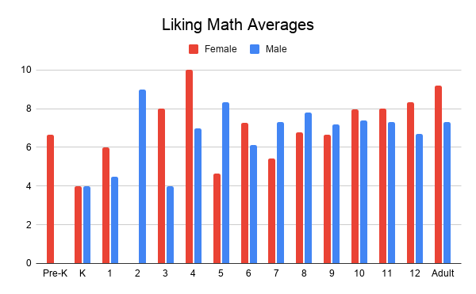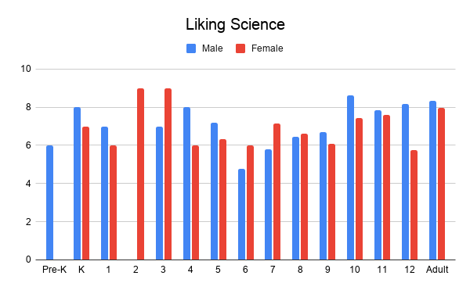

In the category for math importance in figure 11, the team sees a slightly different trend. Figure 11 shows male respondents’ perceptions of math importance sharply increase around 10th grade and remain relatively high through adulthood. In contrast, the female respondents’ perceived importance of math plateaued around 7th grade. This difference in later grade school and adulthood perceptions could be shaped by a number of factors, but one possible explanation. This may be due to the expectation for students, once in high school, to start thinking about career paths. Due to the often higher-paying jobs available in the STEM fields, students are often pushed or directed towards topics like math and science. This may directly affect the student’s responses in the direction of giving the rating of importance for both math and science higher due to the expectation often placed on them to excel in those fields.

When summarizing the average rating by respondents on how much they like math and science in comparison to how important they think it is, the averaged results show a very clear picture. Starting with the average liking by gender and grade in math, shown in figure 12, the team can see it varies drastically in elementary school but begins to stabilize in middle school. From the elementary school respondents, the team see back and forth results for the greatest liking between males and females. In middle school, the team sees the males consistently scoring higher while females seem to take a large dip from where they were averaging in elementary school. In high school, the teams sees a shift in results for females’ liking of math as they consistently score higher than their male counterparts. The same results can be seen in the adult category of scoring. The fluctuations for not only female scoring but male scoring in the elementary school/early middle school years may be due to the adjusting phases that students experience when entering a new school environment with new expectations. Middle school is often viewed as the preparation for high school, and are widely accepted as being very academically taxing due to the higher expectations and all the other chaos associated with middle school. This is a possible explanation for the dip in both male and female respondent scores in the middle school years, and the corresponding higher average for both male and female when students have adapted and adjusted and are comfortably transitioning into the high school years.

When it comes to science liking, depicted in figure 13, the team sees a severe dip in science liking for both females in 12th grade. This result is interesting to us as the team had a higher female response rate, which diluted any outliers in this data, suggesting that for some reason the female 12th graders sampled have reasons for not liking science. Of the 12th grade females sampled, nearly all of them go to Palmetto Scholars Academy, which does not offer science classes on campus for 12 graders, rather, they are sent to a local college to take classes to help pursue their career choices. This team believes this data to be significant because it shows a correlation between not taking science classes in a known and predictable atmosphere and a decrease in science liking. This team believes this trend will be expressed in freshman college students as well, as Palmetto Scholars Academy 12th grades take classes as though they are college freshmen. This outlier is strongly symbolic of the relative dip in between elementary and middle school science liking and could suggest that a similar phenomenon is observed in transitioning college students.

The data collection is still incomplete at this time and these results and the analysis might look different once the team has a larger pool of responses. In reference to the mainly female response, the team believes that may be attributed to the outreach platform utilizing this team member’s parents, mainly the female parent figures platforms to help spread the survey for responses. This being as the team had yet to build a substantial amount of followers.

# Design Summary

“Smells Like Particulate Matter” is studying and collecting data on particulate density, prevalence, size, and levels over time, as well as establishing a baseline for the reliability of certain consumer-grade hardware. This experiment is structured with the SPS30 mounted on top of a Pi HAT supported by 6mm brass standoffs. This team will secure the SPS30 (seen in figure 13) via eight individual solder anchors, and connect it to the HAT with a 5-pin connector standard. The entire configuration will be 65 mm by 56.5 mm by 17.8 mm. The programs will all operate in unison, and based on the initial functional testing, they will be able to collect data, package the data into JSON files, and send the data to the flight computer using the UAH transfer program at a maximum data rate of 0.5 kBps. Outreach at this point in the year has planned a strong outline for outreach content, and have made excellent progress on survey collection with the goal to collect at least 1,000. Next semester outreach will mainly create and publish the majority of the online content and will complete and analyze survey collection.

Throughout this process, this team has learned a lot. This team has learned better methods to work on a compacted timeline, balance workloads, communicate virtually, schedule meetings, collaborate virtually, and run social media platforms. Next semester, the team plans to start work immediately after the holidays, with this team’s first environmental test scheduled for January 11th. The remaining environmental tests will all be completed within the same week, and because of this, The team will have plenty of time to remedy any concerns that arise from testing and implement feedback from future reviews. This team expects next semester to be much smoother, as this team’s relative design simplicity and supporting hardware make this experiment extremely durable, reliable, and resistant to external conditions.

Figure 13. SPS30 Testing Configuration